Shrinkage correlation: GBPUSD and NZDUSD
Method 08 / eight-major panel / delta = 0.2 and Ledoit-Wolf / Alpari D1 full available history

Study setup
Logical pair: GBPUSD , NZDUSD
Broker symbols: GBPUSD_i , NZDUSD_i
Snapshot: 2026-11-03_majors_alpari_D1
Timeframe: D1
Common eight-major panel window: 1999-01-06 to 2026-11-02 (UTC bar dates)
Panel matched return count n: 7127
Dropped unfinished last bar dated 2026-11-03 UTC after a tick-volume check against the prior complete day.
Fixed shrinkage: delta=0.2, mu=3.9170889e-05 (mean of diag(S))
Ledoit-Wolf estimated delta: 0.0042157642
Panel symbols: EURUSD, GBPUSD, AUDUSD, NZDUSD, USDJPY, USDCHF, USDCAD, EURGBP
Complete matched rows (Excel): GBPUSD-NZDUSD_Shrinkage_D1.xlsx
Complete matched rows (HTML table): GBPUSD-NZDUSD_Shrinkage_D1_data.html

Method carried forward
Shrinkage blends the sample covariance matrix S of matched daily log returns of close, ln(close_t / close_t-1), toward a simple target, then converts the shrunk covariance into correlations. Quotes are not inverted. This experiment builds one common calendar across all eight majors, forms S with the unbiased n-1 divisor, then reports two shrinkage specs: fixed delta = 0.2 with mu equal to the average sample variance (mu * I target), and sklearn Ledoit-Wolf with its estimated delta. Pair reports pull rho_ij from those panel matrices. Same-panel Pearson r is a side check only. Shrinkage improves conditioning; it is not a cause, not a lead, and not a trading signal.

Results
pearson_r | rho_02 | rho_LW | rho_02_minus_r | rho_LW_minus_r | delta_LW
0.532783 | 0.431297 | 0.530651 | -0.101486 | -0.002132 | 0.00421576

Conclusion
Over the common 7127-day eight-major panel for GBPUSD and NZDUSD (broker quote directions unchanged), fixed-delta shrinkage correlation at delta=0.2 is 0.4313 (positive, moderate linear link in this sample). Ledoit-Wolf rho is 0.5307 with estimated delta=0.004216. Same-panel Pearson r is 0.5328 (rho_02 minus r = -0.1015; rho_LW minus r = -0.0021). This does not establish cause, lead-lag, or a lasting trading rule.

Charts
Daily closes
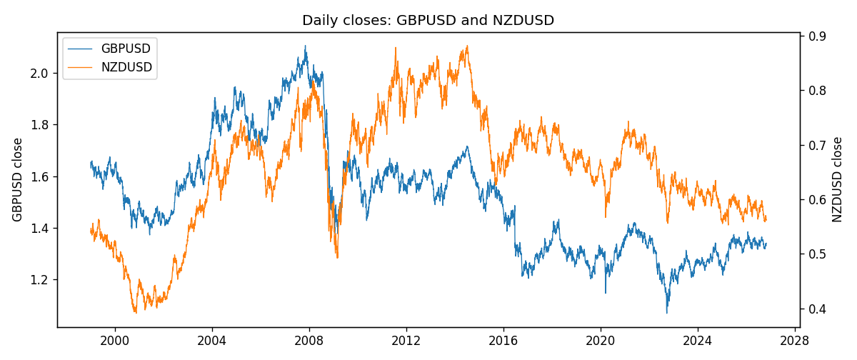
Daily log returns
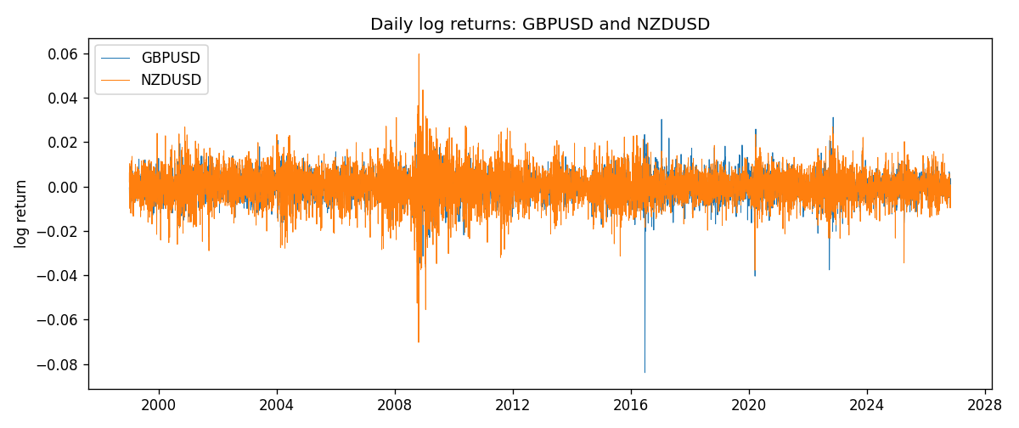
Log-return scatter
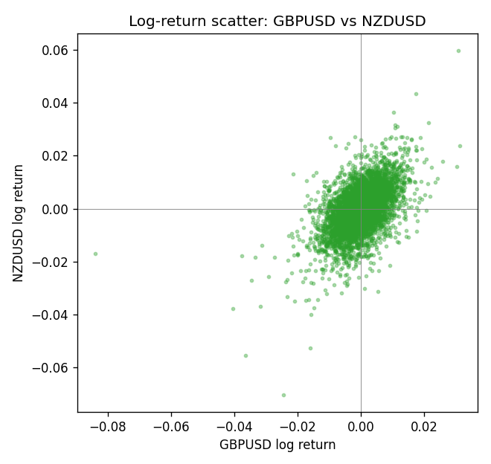

Data report
Every panel row for this pair slice is stored in the sibling Excel workbook named GBPUSD-NZDUSD_Shrinkage_D1.xlsx. Full-panel covariance and correlation matrices are saved once under outputs/ as CSV files. Embedding all rows as a Word table is impractical at this length; the Word file holds the column list, column summaries, and the first and last 15 matched rows.
Columns: time, GBPUSD_open, GBPUSD_high, GBPUSD_low, GBPUSD_close, GBPUSD_tick_volume, GBPUSD_spread, GBPUSD_real_volume, GBPUSD_log_return, NZDUSD_open, NZDUSD_high, NZDUSD_low, NZDUSD_close, NZDUSD_tick_volume, NZDUSD_spread, NZDUSD_real_volume, NZDUSD_log_return
Column summaries (panel rows)
column | count | mean | std | min | 25% | 50% | 75% | max
GBPUSD_open | 7127 | 1.5143204 | 0.21800183 | 1.06854 | 1.323655 | 1.5093 | 1.62967 | 2.1066
GBPUSD_high | 7127 | 1.5206136 | 0.21856742 | 1.08366 | 1.32882 | 1.5159 | 1.636975 | 2.1161
GBPUSD_low | 7127 | 1.508003 | 0.21722806 | 1.03518 | 1.3185 | 1.501 | 1.623 | 2.0983
GBPUSD_close | 7127 | 1.5143843 | 0.21795834 | 1.06879 | 1.32373 | 1.5095 | 1.62965 | 2.1065
GBPUSD_tick_volume | 7127 | 95725.777 | 154086.85 | 62 | 10131.5 | 53562 | 92170 | 1273370
GBPUSD_spread | 7127 | 26.790936 | 19.185969 | 0 | 10 | 20 | 50 | 50
GBPUSD_real_volume | 7127 | 3.5930129e+09 | 8.4874724e+10 | 0 | 0 | 0 | 0 | 2.4038164e+12
GBPUSD_log_return | 7127 | -2.548e-05 | 0.00564718 | -0.08388241 | -0.00312586 | 3.034e-05 | 0.00318105 | 0.03112653
NZDUSD_open | 7127 | 0.65707489 | 0.10792246 | 0.3913 | 0.59224 | 0.66889 | 0.725215 | 0.88218
NZDUSD_high | 7127 | 0.66100044 | 0.10841069 | 0.3961 | 0.595625 | 0.6726 | 0.72964 | 0.88421
NZDUSD_low | 7127 | 0.65338952 | 0.10751648 | 0.3897 | 0.588615 | 0.6651 | 0.721335 | 0.87988
NZDUSD_close | 7127 | 0.65715675 | 0.10791625 | 0.3907 | 0.5923 | 0.66906 | 0.725335 | 0.8822
NZDUSD_tick_volume | 7127 | 69244.396 | 123501.01 | 17 | 5842 | 34224 | 58735 | 1127682
NZDUSD_spread | 7127 | 30.023572 | 25.540824 | 0 | 9 | 17 | 40 | 80
NZDUSD_real_volume | 7127 | 1.6834718e+10 | 8.5315436e+10 | 0 | 0 | 0 | 0 | 2.705649e+12
NZDUSD_log_return | 7127 | 2.447e-05 | 0.00764665 | -0.07027433 | -0.00423198 | 0.00024001 | 0.00459119 | 0.05966839
First 15 panel rows (selected columns)
time | GBPUSD_close | NZDUSD_close | GBPUSD_log_return | NZDUSD_log_return
1999-01-06 | 1.6537 | 0.5383 | -0.00060452184 | 0.0020455609
1999-01-07 | 1.6502 | 0.5417 | -0.002118709 | 0.0062963171
1999-01-08 | 1.6405 | 0.5414 | -0.0058954193 | -0.00055396548
1999-01-11 | 1.6312 | 0.547 | -0.0056851331 | 0.010290425
1999-01-12 | 1.6349 | 0.5441 | 0.0022657001 | -0.0053157489
1999-01-13 | 1.6499 | 0.5387 | 0.0091330396 | -0.0099742238
1999-01-14 | 1.6531 | 0.5386 | 0.0019376331 | -0.00018564931
1999-01-15 | 1.6502 | 0.5382 | -0.0017558204 | -0.00074294208
1999-01-18 | 1.6522 | 0.5372 | 0.0012112405 | -0.0018597736
1999-01-19 | 1.6553 | 0.5382 | 0.0018745281 | 0.0018597736
1999-01-20 | 1.6472 | 0.5404 | -0.0049053846 | 0.0040793678
1999-01-21 | 1.6524 | 0.5426 | 0.0031518998 | 0.0040627941
1999-01-22 | 1.6565 | 0.5361 | 0.0024781662 | -0.012051689
1999-01-25 | 1.6585 | 0.5342 | 0.0012066366 | -0.0035504102
1999-01-26 | 1.6597 | 0.5381 | 0.00072328374 | 0.0072741158
Last 15 panel rows (selected columns)
time | GBPUSD_close | NZDUSD_close | GBPUSD_log_return | NZDUSD_log_return
2026-10-13 | 1.32534 | 0.56127 | 0.0036434319 | 0.0047326165
2026-10-14 | 1.31884 | 0.55918 | -0.0049164679 | -0.0037306483
2026-10-15 | 1.32757 | 0.56185 | 0.0065976411 | 0.0047634855
2026-10-16 | 1.33257 | 0.56509 | 0.0037592051 | 0.0057501001
2026-10-19 | 1.33024 | 0.56616 | -0.0017500314 | 0.0018917133
2026-10-20 | 1.3377 | 0.56827 | 0.0055923442 | 0.0037199341
2026-10-21 | 1.33937 | 0.57003 | 0.0012476328 | 0.0030923331
2026-10-22 | 1.33967 | 0.56815 | 0.00022396082 | -0.0033035227
2026-10-23 | 1.33684 | 0.56991 | -0.0021146949 | 0.0030929853
2026-10-26 | 1.33359 | 0.56826 | -0.0024340661 | -0.0028993932
2026-10-27 | 1.33044 | 0.56811 | -0.0023648393 | -0.00026399852
2026-10-28 | 1.33254 | 0.56261 | 0.0015771808 | -0.0097283914
2026-10-29 | 1.33733 | 0.56296 | 0.0035881935 | 0.00062190714
2026-10-30 | 1.33913 | 0.56307 | 0.0013450605 | 0.00019537668
2026-11-02 | 1.3406 | 0.56161 | 0.0010971256 | -0.0025962955

